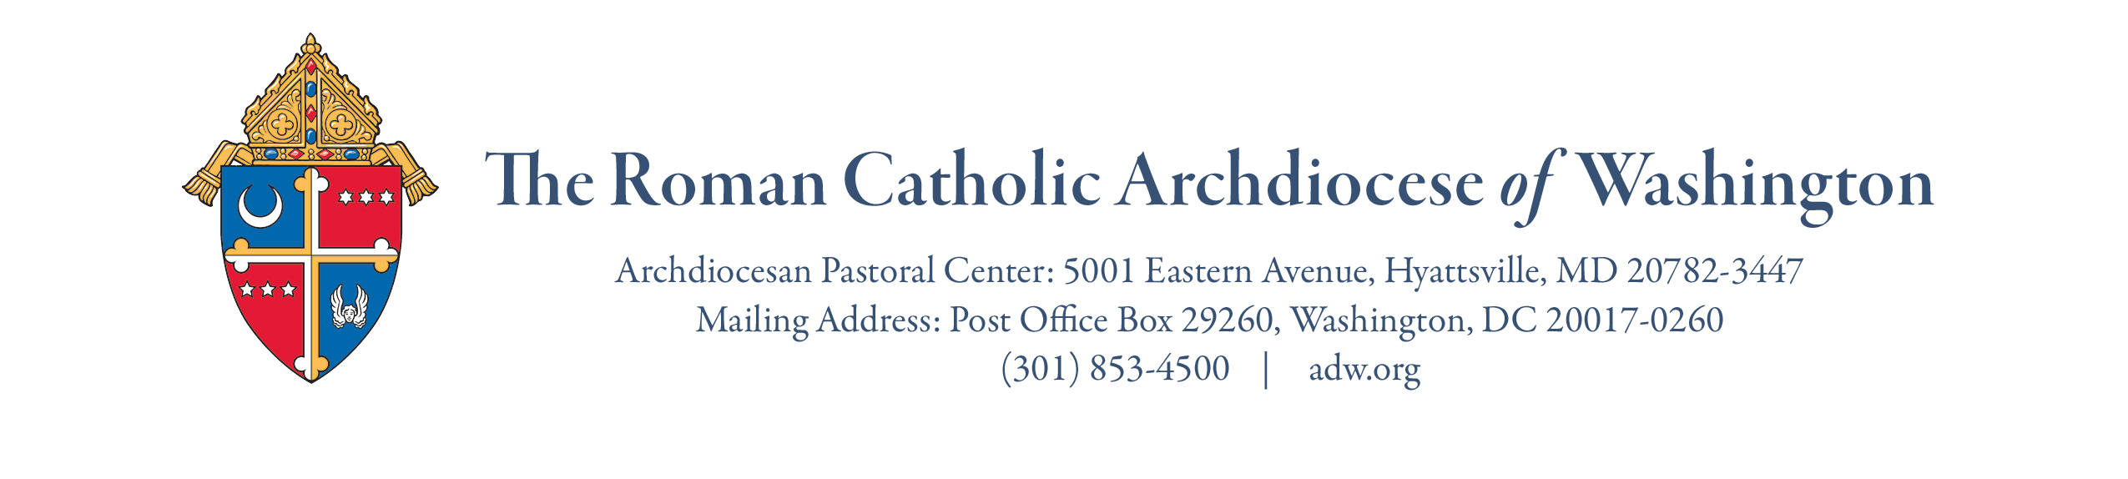
Office of Social Concerns
Community Food Security Program – Quarterly Grant Application

Description
In response to needs associated with the onset of the COVID pandemic, the Archdiocese of Washington launched the Parish Pantry Support Project (PPSP) in July 2020 to provide vital support for parish-based food pantry programs, with the first grant distributed on July 31, 2020. Due to abundant requests and growing need, the PPSP was renamed the Community Food Security Program (CFSP) and expanded to include related parish food programs and pantries or food assistance programs at Catholic schools. As of January 2023, grants have also been extended to pantries and certain hunger prevention programs of Catholic organizations and ministries working closely with parishes or schools of the Archdiocese of Washington.

The Community Food Security Program has awarded more than $750,000 in renewable grants since July 2020, that include awards to fifty (50) parish and five (5) school food pantries and meal programs. The Secretariat of Development works with individual and foundation donors throughout the year to recharge the Community Food Security Program reserves. The Office of Social Concerns directs the program and receives, evaluates, and processes grant requests on a quarterly basis as described here.

Guidelines
To apply, please complete the following form and submit to Ian Mitchell, Director of the Office of Social Concerns at mitchelli@adw.org.

- Parishes, schools, and closely associated local Catholic ministries/organizations may request a grant at a level that is appropriate for their program need up to $5,000. Grants may be renewed through a fresh application on a quarterly basis as outlined below.

Grant Period | Due Date  of Application | Grant Disbursement Projected Date
Quarter 1 | June 30 | July 31
Quarter 2 | September 30 | October 31
Quarter 3 | December 31 | January 31
Quarter 4 | March 31 | April 30

- We have designed the application to be no more than one page to minimize administrative paperwork for the pastor/principal, but we ask that you complete all application rows, including the estimated number of people the food pantry and/or meal program serves, on average, per quarter (3-month period).
- The Office of Social Concerns will review applications quarterly and provide a decision by email to the pastor and food program lead contact listed in the application. The Archdiocese’s Finance Office will disburse the grant funds close to the projected disbursement date above (usually via electronic transfer).
- For Grant Renewals: At the time of application, please include in your grant request email a “picture and paragraph” story or testimonial that highlights your program. The Secretariat for Development and Office of Social Concerns use these stories to supplement outcomes and impact reports to the faithful and donors. Grant recipients may on occasion be asked to provide further information or reports.
Application Form – Community Food Security Program Quarterly Grant
(Please complete all rows and all required signatures.)

Date of Request:

Parish/School/Organization Name:
Address:
County:
Pastor/Principal/Director Name:
Name of Pantry/Program:

Food Pantry/Program Coordinator:

Food Coordinator Phone Number and Email Address:
Other Applicant Phone Number and Email (if another is completing app):
Name of Pantry/Program:
Any additional Catholic parishes or schools that may jointly participate in or assist your program (if applicable)?
On average, how many people does your food pantry or program serve per month?
In what ways are you serving people through your program (example: grocery bags of pantry items, hot meals served, grocery store gift cards, etc.)
Amount Requested?
(Maximum of $5,000 per quarter.)
Reminder – Renewal Applications: Is a “picture & paragraph” short story included in your submission email?

Pastor Signature Date

Principal or Executive Director Signature (if applicable) Date
(Revised 11-2023)

