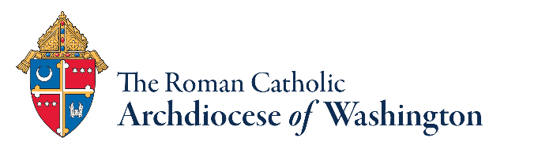
Universal Prayer – Native American Heritage Month

- For the Church, for unity among its leaders and peace among the faithful. Draw your Church together into one company of disciples, walking together, serving you in your mission in the world, and witnessing your love.
Let us pray to the Lord.

- For the Church, may the Holy Spirit call forth holy and wise pastoral leaders to preach the good news of Jesus with courage and meekness as we encounter different cultures among the faithful, let us pray to the Lord.

- For those who work for the good of people everywhere, they can hear from every mouth of every peoples the hunger for hope and honor the gifts of all traditions. Let us pray to the Lord.

- For national and civic leaders, may they receive the grace and blessing of our almighty God in performing their duties, Let us pray to the Lord.

- For those who suffer the effects of the systematic oppression of indigenous sovereignty, language, and culture, for a renewal of hope and a willingness to grow. Let us pray to the Lord.

- For the chronically ill, especially those mentioned in our parish prayer book, may the healing strength of the Lord carry them through whatever obstacles and difficulties they encounter, Let us pray to the Lord.

- For us, help us to receive gifts of wisdom from all peoples. Help us to grow our roots deeper through life’s journey, that we may grow in kindness to ourselves and each other. Let us pray to the Lord.

- For all who are called in ministry to minister to people of the First Nations, may they experience joy in Christ, let us pray to the Lord. Let us pray to the Lord.

