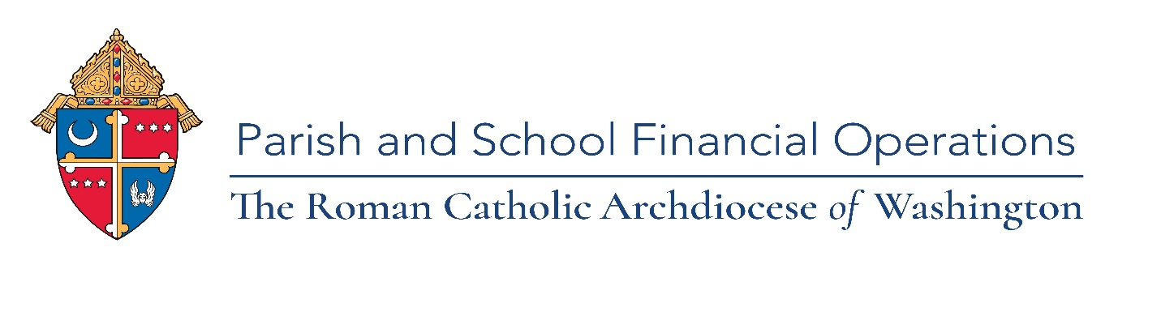

**Calendar 2023 ParishSOFT Training Webinars**

**Ledgers & Payables and Family Suite**

Please mark your calendar for our 2023 training classes led by our ParishSOFT vendor via webinar. Registration links will be emailed prior to each class. Each training webinar will be recorded and available on the Parish & School Financial Operations webpage for all to view after the training. If you have any questions, please contact Florence Moore, Senior Operations Accountant at [MooreF@ADW.org](mailto:MooreF@ADW.org) or 301-853-5386.

* January 10, 2023, Tuesday, Family Suite -Family Directory Basics Part 1 10am-11:30am

Main/Home Screen, Family List, Adding a family (repeats March 7, 2023)

*Suggested for: New/untrained Secretary/Bookkeeper/Family Suite use****r***

* January 19, 2023, Thursday, Family Suite -Family Directory Basics Part 2 1pm-2pm

Member Details, Member list, and Reports

*Suggested for: New/untrained Secretary/Bookkeeper/Family Suite use*

* February 9, 2023, Thursday, Ledgers & Payables -Reporting 10am-11:30am

Filtering, columns and Sorting, Report Options, Report Navigation, Month/Year End Reports

*Suggested for: New/untrained Bookkeeper/Pastor*

* February 16, 2023, Thursday, Family Suite – Administration 10am-11am

Suspense, My Own Church, Lookup Management, Adding new staff, Module Settings and Notifications

*Suggested for: Secretary/Family Suite user/Coordinator*

* March 7, 2023, Tuesday, Family Suite -Family Directory Basics Part 1 9am-10:30am

Main/Home Screen, Family List, Adding a family

*Suggested for: New/untrained Secretary/Bookkeeper/Family Suite use****r***

* March 8, 2023, Wednesday, Family Suite -Family Directory Basics Part 2 10am-11am

Member Details, Member list, and Reports

*Suggested for: New/untrained Secretary/Bookkeeper/Family Suite use*

* March 16, 2023, Thursday, Family Suite -Offering Basics 10am-11am

Batches, Contribution Posting, Editing Contributions, and Giving History

*Suggested for: New/untrained Secretary/Bookkeeper/Family Suite use****r***

* April 20, 2023, Thursday, Family Suite – Offering Advanced 10am-11am

Fund management, Correction Batches, and How to Customize EOY Statements, and additional Reports

*Suggested for: Secretary/Family Suite user/Coordinator*

* April 26, 2023, Wednesday, Ledgers and Payables -Budget Entry 10am-11am

Add, Update and Remove Budget, Send and Receive Budgets, Import Budget, and Reports

*Suggested for: Bookkeeper/Pastor*

* May 4, 2023, Thursday, Family Suite – Administration 10am-11am

Suspense, My Own Church, Lookup Management, Adding new staff, Module Settings and Notifications

*Suggested for: Secretary/Family Suite user/Coordinator*

* May 11, 2023, Thursday, Family Suite – Workgroups & Communication 10am-11pm

Creating and managing Member & Family workgroups, Emailing in PS, Life Events and Basic Mail merge

*Suggested for: Secretary/Family Suite user/Coordinator*

* June 14, 2023, Wednesday, Family Suite Intelligent Query 10am-11am

Building queries, Sorting Results Columns, Query Tags, Saving and Modifying Queries, and Queries Results Opportunities

*Suggested for: Bookkeeper/Family Suite user/Coordinator*

ADW.org Parish and School Financial Operations page [YouTube playlist for training videos and webinars](https://youtube.com/playlist?list=PL91HXPLFFAxN9Clwx1vnEUQdPHZxiqh0b)

Free ParishSOFT online Training- Pathfinder click the link:

<https://adw.org/wp-content/uploads/sites/2/2020/03/ParishSOFT-Software-Video-Learning.pdf>

Free ParishSOFT support [Support@ParishSoft.com](mailto:Support@ParishSoft.com) for any questions.

Free Excel link to a list of dates for live webinars: <https://www.cpaacademy.org/series/MicrosoftExcel>