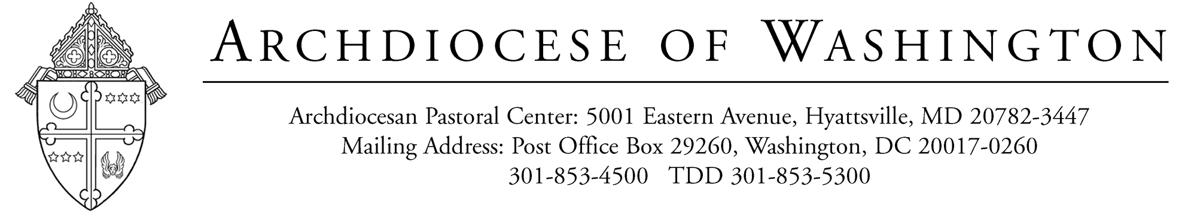

November 18, 2022

Dear Father/Monsignor:

Please see below which I hope will be of help to you in preparing your income tax returns for 2022.

Retired priests of the Archdiocese are afforded a Housing Allowance or are provided housing by the Archdiocese. The Housing Allowance for 2022 was $3,600.

I. Retired Priests Living ON Church Property:

(a) The Archdiocesan Retirement Plan for priests is not a qualified pension plan.
(b) All Archdiocesan retired priests will receive a Form 1099-R
(c) Your retirement compensation should be reported on Form 1040.
(d) The amount reported on Form 1099-R is not subject to self-employment tax. This amount is NOT to be reported on Schedule SE.

II. Retired Priests Living OFF Church Property: (In addition to the above, the following applies to priests who live off Church property)

(a) The amount designated as Housing Allowance is NOT reported on your 1099-R

(b) The Housing Allowance of $3,600 is excluded from gross income to the extent that such allowance is used for rent (including utilities) or otherwise provides shelter. Any excess Housing Allowance should be reported on Form 1040 as Other Income.

Each priest is responsible for completing and filing his own income tax forms. The tax laws are complex; therefore, before you prepare your income tax returns, we recommend that you consult with a tax accountant. If you need a tax accountant, we can provide you with names of individuals who are familiar with preparing income tax returns for priests.

If you need additional details, please feel free to call me at (301) 853-4497.

Sincerely yours,

Angela Ossinger
Director HRIS & Benefits

