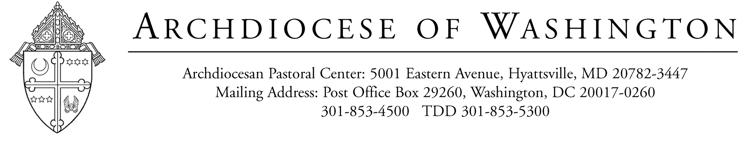

November 18, 2022

Dear Father/Monsignor:

All Archdiocesan priests will have their W-2 and 1095-C Forms available in CHRIS from their parish or agency by January 31, 2023.

Archdiocesan priests should have received their salary payment and an expense advance each month. The parish/agency bookkeeper should receive from archdiocesan priests the necessary documentation to support the Expense Advance no later than January 1, 2023; otherwise, all undocumented expenses will be added as taxable income to your W-2 Statement, which may result in an increase in your tax liability. For your convenience, an Expense Advance Documentation Summary sheet is enclosed. Since all parishes utilize CHRIS, the W-2s are prepared in conjunction with our vendor. Due to the tight timeframe for preparation, January 1, 2023 is the final date to submit your documented expenses to the bookkeeper.

For the tax year 2022, archdiocesan priests are considered employees for federal income tax purposes. However, for social security purposes, archdiocesan priests are considered self-employed. Each priest must complete and file Form 1040 and the Long Form Schedule SE.

If you have other income and expenses, you may be required to complete and file other forms and schedules in support of your Form 1040. For example, if you have received stipends and honoraria, you may be required to prepare Schedule C.

The Form Schedule SE is completed to determine your social security tax liability. You should prepare an attachment to this Schedule which shows the amount to be entered on line 5A. We recommend the following format:

Your Name:
Your Address:
Social Security #

Attachment to Long Form Schedule SE, Line 5a Church Employee Income:

Salary as a Catholic Priest, per W-2 X,XXX.XX
Plus Value of Housing Provided 3,600.00

Total Church Employee Income X,XXX.XX*

*The total amount for Church employee income is then multiplied by .9235 and the amount is entered on Line 5b.

You are to complete the remaining lines appearing on the Long Form Schedule SE to determine your self-employment tax.

Each priest is responsible for completing and filing his own income tax forms. The tax laws are complex; therefore, before you prepare your income tax returns, we recommend you consult with a tax accountant. If you need a tax accountant, we can provide you with names of individuals who are familiar with preparing income tax returns for priests.

For those priests who will be turning 65 in the 2023 calendar year, please remember to enroll in Medicare. You can enroll as early as 3 months prior to your date of birth.

If you need additional details concerning the above, please feel free to call me, at 301-853-4497.

Sincerely yours,

Angela Ossinger
Director, HRIS & Benefits

Enclosure

