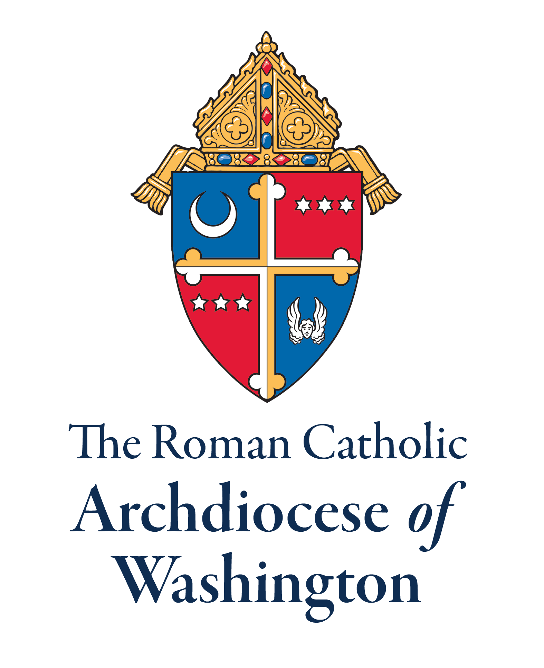
Parish Guide for Registration
First Annual Wedding Anniversary Mass to Celebrate the Vocation of Marriage
Basilica of the National Shrine of the Immaculate Conception
Saturday, August 20, 2022, 9:30 a.m.

Step #1: Publicize and Collect Information:
Beginning now through August 5, announce the Wedding Anniversary Mass to Celebrate the Vocation of Marriage in your parish bulletin, Flocknote messages, announcements, etc. (see sample announcements in the promotional materials.) Ask couples to complete the application (link provided) to receive a certificate from Cardinal Gregory in recognition of their anniversary.

Step #2: Couples representing their parish at the Mass:
Step-by-step Instructions for Online Registration (must be completed by August 5):

Each pastor or their delegate is asked to select up to three couples, regardless of their anniversary date, that will represent their parish. Selected couples should be diverse as to anniversary date and representative of the parish. When compiling the registration information from the couple, please ask if they have a special story to share. To download both the application to receive a certificate, and the form to submit the names of the couples that will represent the parish, please go to Parish Office Only section of adw.org (To access this page, enter username [parish] and password [briefings]. No capital letters.) Send completed parish representative form to Sally Daniel flm@adw.org

Notes:
- The Parish Only website section will include:
  - The registration form for the pastor or his delegate to complete the names of the three couples that will represent their parish
  - The application link for a certificate from Cardinal Gregory in recognition of anniversary for all couples. English - https://www.surveymonkey.com/r/GVKRC73
Spanish - https://es.surveymonkey.com/r/GV7RVPT

- Please contact Sally Daniel, Office for Family Life, at 301-853-4546 or flm@adw.org if you have any difficulty with registration.

