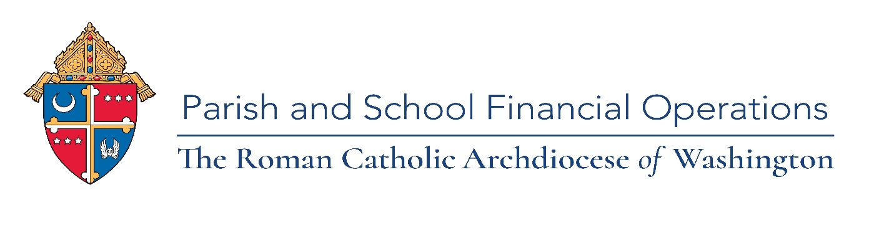

**Calendar 2022 ParishSOFT Training Webinars**

**Ledgers & Payables and Family Suite**

Please mark your calendar for our 2022 training classes led by our ParishSOFT vendor via webinar. Registration links will be emailed prior to each class. Each training webinar will be recorded and posted to the Parish & School Financial Operations webpage for all to view after the training. If you have any questions, please contact Florence Moore, Senior Operations Accountant at [MooreF@ADW.org](mailto:MooreF@ADW.org) or 301-853-5386.

* January 18, 2022, Tuesday Family Suite -Family Directory Basics 10am-12:30pm hands on Basics (Pick 1 January 18, February 3 or March 2)

*Suggested for: New/untrained Secretary/Bookkeeper/Family Suite use****r***

* February 3, 2022, Thursday, Family Suite -Family Directory Basics 12:30pm -3pm. See January 18 for description.

* February 17, 2022, Thursday, Ledgers & Payables -Reporting 10am-12pm

*Suggested for: New/untrained Bookkeeper/Pastor*

* March 2, 2022, Wednesday, Family Suite -Family Directory Basics 10am-12:30pm. See January 18 for description.
* March 23, 2022, Wednesday, Family Suite -Offering 10am-12pm

*Suggested for: Secretary/Family Suite user*

* April 27, 2022, Wednesday, Ledgers and Payables -Budget Entry 10am-11am

*Suggested for: Bookkeeper/Pastor*

* May 24, 2022, Tuesday, Family Suite - Admin & Workgroups 10am-12pm

*Suggested for: Secretary/Family Suite user*

* June 16, 2022, Thursday, Family Suite 10am-1pm, 2 sessions

Advanced Offering - *Suggested for: Secretary/Family Suite user*

Intelligent Query - *Suggested for: Bookkeeper/Family Suite user*

Free ParishSOFT online Training- Pathfinder click the link:

<https://adw.org/wp-content/uploads/sites/2/2020/03/ParishSOFT-Software-Video-Learning.pdf>

Free ParishSOFT support [Support@ParishSoft.com](mailto:Support@ParishSoft.com) for any questions.

Free Excel link to a list of dates for live webinars: <https://www.cpaacademy.org/series/MicrosoftExcel>

December 22, 2021