Website: http://diocesanrequest20.eventbrite.com
Password: 20DLTR

Please follow the new instructions carefully.

After you go to the website and enter the password, you will see the follow screen:

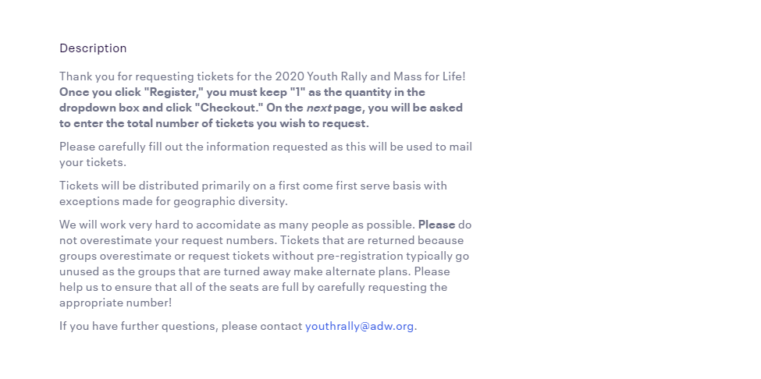

As the instructions indicate, click “Register.” You will then see this window:

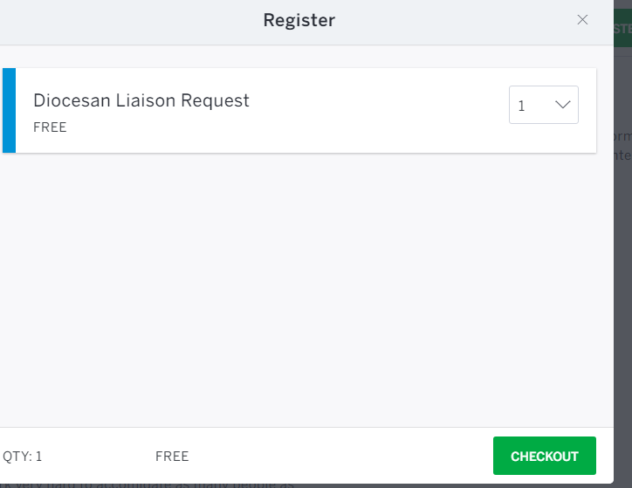
You will not be able to change the Quantity to anything other than “1.” Simply click “Checkout.”

On the following page, you will see this box at the top:

This is to be expected.

Please complete the form with all the information requested.

One of the required questions will ask you how many tickets you wish to request. In this box, enter your request number. For example, if I were to request 250 tickets, I would enter:
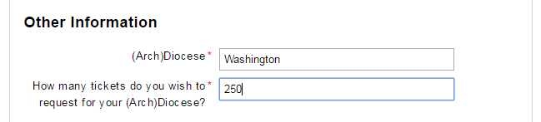

On the confirmation page after you submit your registration, it will look like you only requested 1 ticket. Don’t worry.
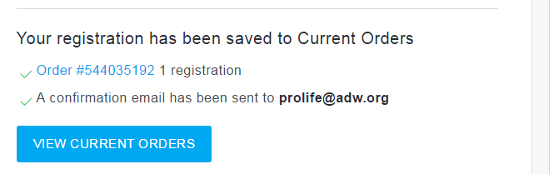

Right below, you will see your actual ticket request number. We will use this number to determine your ticket allotment.
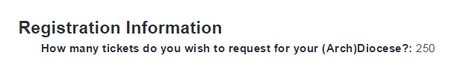

You will see the same information in your confirmation email. It should look like this:

