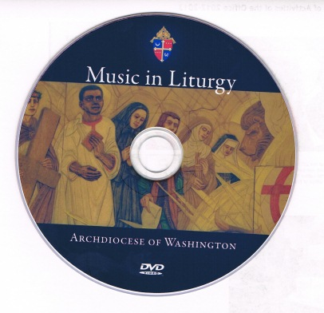
$ 6.00

Music has always been a part of the worship life of the faithful. The African American Catholic voice is lifted up in praise and worship every time we gather at the liturgy. The exuberant and participatory expression of Gospel music you find in African American parishes is a wonderful example of the “New Evangelization” which the church has embraced. This video produced by the Office of Black Catholics and the Office of Multimedia celebrates the diversity of worship practices and spiritualties which are the strength of our church. This Music in Liturgy video touches on how we are “Truly Black and Authentically Catholic” Order your copy today by Fax or mail using the order form below.

_______________________________________________________________________

Order for Music in Liturgy Video

Please send______copies of Music in Liturgy
Enclosed is $________ Make check or money order payable to “Office of Black Catholics, ADW.”
[Print or type the following information]:

NAME___________________________________
ADDRESS:______________________________________________________
Zip Code:________________ Phone and/or e-mail.____________________

Mail this Order form to: Office of Black Catholics, P.O. Box 29260, Washington, DC 20017-0260. Phone: 301-853-4469 Fax: 301-853-7671
E-Mail: mailto:colesbells@adw.org

