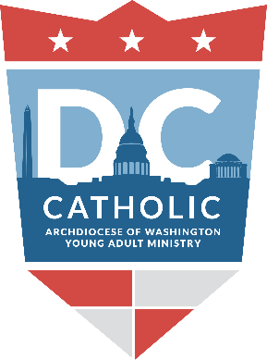

Archdiocese of Washington Office of Young Adult Ministry

2017-2018 Washington, D.C. Calendar of Events

July
22-WYD Unite, St. John Paul II Shrine
11-DC Theology on Tap, Buffalo Billiards
18-DC Theology on Tap, Buffalo Billiards
25-DC Theology on Tap, Buffalo Billiards

August
1-DC Theology on Tap, Buffalo Billiards
20-YA Leader Training, Holy Rosary Parish

September
11-Month of Service September 11-October 11
12-DC Theology on Tap, Buffalo Billiards
16-Archdiocesan Men’s Conference
23-Oktoberfest, St. Thomas Apostle
30- Spanish Catholic Center Gala

October
10--DC Theology on Tap, Buffalo Billiards
11-Month of Service September 11-October 11
13-14 YA Retreat with Fr. Mark Ivany
28-Catechetical Day (formation opportunity)

November
14-DC Theology on Tap, Buffalo Billiards

December
9-Walk with Mary (Guadalupe Pilgrimage/Mass)
12-DC Theology on Tap, Buffalo Billiards

January
9-DC Theology on Tap, Buffalo Billiards
14-YA Leader Training, Holy Rosary Parish
19-March for Life
26-27 YA Retreat with Fr. James Brent O.P

February
13-DC Theology on Tap, Buffalo Billiards
14-Ash Wednesday
17-Light the City, Cathedral of St. Matthew

March
13-DC Theology on Tap, Buffalo Billiards
24-7 Church Walk, Downtown DC

April
1-Easter
10-DC Theology on Tap, Buffalo Billiards

May
8-DC Theology on Tap, Buffalo Billiards

June
12-DC Theology on Tap, Buffalo Billiards

