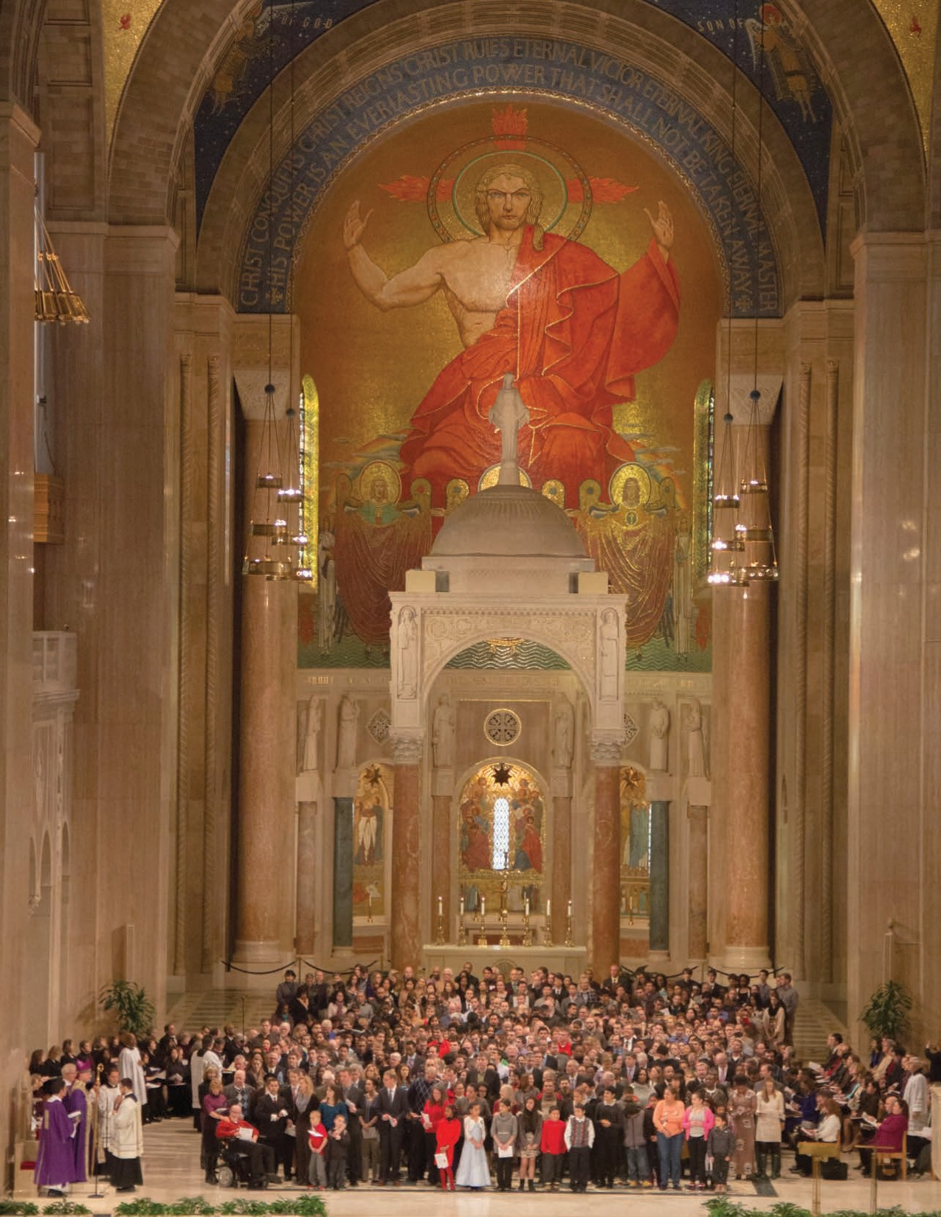**CATHOLIC IDENTITY INITIATIVE**

**PASTORS TOOLKIT**

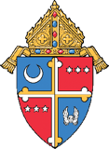

Archdiocese of   
 Washington

**INTRODUCTION**

Cardinal Wuerl’s pastoral letter, *Being Catholic Today: Catholic Identity in an Age of Challenge* highlights the mission of the Church, to evangelize, teach, worship and serve, and the important role of employees in participating in the work of the church.

Whether or not they are Catholic, “those who agree to assist the Church in her mission and ministries represent the public face of the Church.” (*Being Catholic Today: Catholic Identity in an Age of Challenge,* p. 14)

Therefore, all employees of the Archdiocese are required to participate in ongoing formation. The formation is a unique opportunity for employees of the Archdiocese to strengthen and maintain Catholic identity as a source of conviction and pride; the *Catholic Identity Initiative Toolkit* is designed to assist Pastors in the implementation.

##### CATHOLIC IDENTITY INITIATIVE

**PASTORS TOOLKIT**

**TABLE OF CONTENTS**

Why, When, Who, and How 2

Check Lists 3

Draft Letter to Employees, from Pastors 4

Frequently Asked Questions 5

Annual Employee Mass for Employees and Commissioning Rite 6

Sample Certificate of Commissioning 7

Commissioning Registration Form. 8

HR Policy: Catholic Ministry Formation Flyer for Parish Employees 9

Appendices

*Being Catholic Today: Catholic Identity in the Age of Challenge Being Catholic Today Workbook*

##### WHY COMMISSION

Commissioning of all employees (both Catholic and Non-Catholic) and lay people with ministerial roles in the Church seeks to celebrate, highlight and publicly thank those who dedicate themselves to serving Christ in His mission. Participation in the commissioning gives employees and lay people with ministerial roles an opportunity to affirm their commitment to both participate in the work of the Church and to “respect our Catholic identity and avoid behavior that contradicts the very mission of the Catholic institution.“ (*Being Catholic Today: Catholic Identity in an Age of Challenge* p. 14.)

##### WHO TO COMMISSION

All paid parish and school employees, full or part time, Catholic and Non Catholic, for example, Directors of Religious Education, Principals, Teachers, Coordinators of Youth Ministry, Choir Directors, Parish Secretaries, Administrators, Bookkeepers, and, all lay people with ministerial roles (catechists, parish advisory and finance council members, youth ministry leaders, lectors, Eucharistic ministers.) Janitors and security staff are examples of those for whom it is not required. If the pastor does not think it appropriate to commission a paid staff person, he must seek an exemption from the Moderator of the Curia

##### WHEN TO COMMISSION

Commissioning takes place within the first months that a new employee is hired. Commissioning can take place at any Mass or other liturgy as determined by the Pastor or on such days as Catechetical Sunday, Staff Retreat, Parish Day of Reflection, Stewardship Sunday, and at any Sunday Mass in Ordinary Time. It is up to the Pastor to select a date(s) which are compatible with the parish calendar. Employees only need to be commissioned once for the specific job that they do. Once commissioned, unless they take on a new responsibility, they do not need to be re-commissioned annually.

##### HOW TO COMMISSION

Commissioning takes place during Mass immediately following the homily prior to the Universal Prayer or at the liturgy celebration. A sample Commissioning Rite is included on page 6.

*\*Catholic school administrators and teachers are commissioned at the Annual Archdiocesan Opening of Schools Mass. Faculty and staff who did not attend the Annual Archdiocesan Opening of Schools Mass along with new hires, should be commissioned through the parish.*

**CHECK LIST:** COMMISSIONING

Identify Employees to be Commissioned. Identify volunteers to be Commissioned. Set date for Commissioning Mass.

Set date for annual Catholic Identity parish in-service for all employees and volunteers. Topic to be determined by Pastor. The Secretaries for Pastoral Ministry and Social Concerns and Edcuation have designed four workshops related to mission and spirituality that provide content for an in-service. You can find them a[t www.adw.org/formation.](http://www.adw.org/formation)

Invite/notify employees and volunteers using draft notification letter. Make a copy of employee notification letters and place in employee file.

Assist staff to determine the best date for their participation in a Living Catholic workshop. For schedule and location of workshops refer staff t[o www.adw.org/formation.](http://www.adw.org/formation)

Hold Commissioning Mass/liturgy.

Present Certificate of Commissioning to those commissioned. See p.7 for a sample certificate which is available for download a[t http://clergy.adw.org/login.](http://clergy.adw.org/login) Place copy of Certificate in

employee file.

**CHECK LIST:** FORMATION

Select facilitator and set date for parish *Being Catholic Today: Catholic Identity in the Age of Challenge*

two hour workshop.

Update employee record in CHRIS to reflect completion of formational requirement. Complete and submit the Volunteer Commission Form (see p. 8).

##### DRAFT LETTER TO EMPLOYEES, FROM PASTORS:

Dear (Employee Name),

As together we endeavor to live out Jesus’ call to missionary discipleship (Matthew 28:16-20), I recognize with gratitude your essential work as an employee in the ministry of (Parish/School Name). Supporting and strengthening the Catholic identity of all employees and staff, as described in Cardinal Wuerl’s pastoral

letter, *Being Catholic Today: Catholic Identity in an Age of Challenge,* is essential to the ongoing success of our mission.

The archdiocese has initiated some practical ways to further recognize and support the vital role of those who assist in the ministry of the Church. For example, following the commissioning of all those with a ministerial role in the parish and school this past summer/fall, we had a chance to reflect upon Cardinal Wuerl’s pastoral letter through the “Being Catholic Today” workshop we did on (date) (or indicate date on which workshop is planned).

Looking to the future, the archdiocese has created professional development opportunities for all archdiocesan employees, including a one-day workshop on the basics of the faith and evangelization. (Current employees must complete Living Catholic by June 30, 2018; new employees have two years from the date of hire).

Thank you again for your service to (Parish/School Name), and please know of my prayers as we work together to further the mission of the Church.

Sincerely in Christ, Fr. (Pastor Name)

Catholic Identity Formation for ADW Employees:

##### FREQUENTLY ASKED QUESTIONS

###### If I completed Living Catholic before April 18, 2016, do I need to complete it again?

No, if an employee completed either the live or online version of Living Catholic prior to 4/18/16, they are not required to do so again. Proven record of completion is required. Employees who began, but did not complete, the online course are required to participate in the one-day format of Living Catholic.

###### I’m not Catholic; do I have to take Living Catholic?

Anyone employed by the Church agrees to assist in carrying out the mission and ministry of the Church in a public way. This means that Catholic and non-Catholic employees alike are expected to understand and uphold Catholic Identity.

###### Are Deacons or Religious required to complete the course?

No. Deacons and Religious are formed and receive commissioning by virtue of their ordination/or by their religious profession.

###### Is maintenance and/or housekeeping staff required to complete the course?

Pastors may use their discretion to determine whether custodial staff needs to complete the course. A letter of request for exemption should be sent to the Moderator of the Curia identifying the name of the individual and the reason for exemption. Once exemptions are approved, HR will update the employee record accordingly.

###### How Do I Complete Living Catholic?

Living Catholic will be offered during the regular work day. There will be plenty of options that will work for most employees schedules. You will not have to use vacation or non-related illness (NRI) to cover your absence from the office. If needed, Living Catholic can be presented on a Saturday to accommodate part- time employees who hold other jobs during the week.

###### If I am a certified catechist, am I required to participate in the Living Catholic?

If Living Catholic was completed as part of the certification process, they do not need to take Living Catholic again. However, if catechists/teachers had already completed several formation courses under Hearts Aflame and were not required to take Living Catholic for certification, they are required to complete Living Catholic. The employee requirement is not made from the certification standpoint; rather, it derives from whether or not an employee has completed Living Catholic.

###### Is Living Catholic available in Spanish?

Yes, Living Catholic is available in Spanish.

###### Who do I contact to host a course at my parish?

For Living Catholic: Mission and Ministry contact: Kately Javier (javierk@adw.org) or 301-853-5384.

##### ANNUAL EMPLOYEE MASS FOR EMPLOYEES AND COMMISSIONING RITE

*After the Homily, the Pastor stands at the chair*

Please stand.

Dear friends in Christ, Saint Paul writes, “There are different kinds

of spiritual gifts but the same Spirit; there are different forms of service but the same Lord;

there are different workings

but the same God who produces

all of them in everyone.” (1 Corinthians 12:4-6)

The needs of the Church are many and varied,

but God shows his goodness by sending co-workers

to care for the Church.

Now we ask God

to bless our sisters and brothers who have declared their willingness to serve in (parish or school)

of the Archdiocese of Washington with their many gifts.

My sisters and brothers, Jesus taught us: “You did not choose me;

no, I chose you,

and I commissioned you to go out and bear fruit, fruit that will last.” (John 15:16)

(And so I ask you,)

Do you commit to serve and continue

to grow as missionary disciples of the Lord, recognizing your important role participating in the ministry and mission of his Church?

***Staff: R. / I do.***

##### SAMPLE CERTIFICATE OF COMMISSIONING

Commissioning%20Certificates%202017%20-%20Parish%20Template.pdf

**COMMISSIONING REGISTRATION FORM**

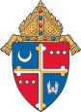 **Archdiocese of Washington**

**Commissioning Registration Form**

|  |
| --- |
| **Please complete and submit the following form within two (2) weeks of commissioning to Stephen DeMauri at** [**demauris@adw.org**](mailto:demauris@adw.org) |

|  |  |  |  |  |
| --- | --- | --- | --- | --- |
| **Parish Name** | **Parish Address** | **Name of Pastor** | **Date of Commissioning** | **Name of person completing this form** |
|  |  |  |  |  |

|  |  |  |  |  |
| --- | --- | --- | --- | --- |
| **#** | **Full Name of Recipient** | **Full or Part Parish Time Employee**  **F / PT** | **Lay Volunteer**  **YES / NO** | **Ministerial Role** |
| **1** |  |  |  |  |
| **2** |  |  |  |  |
| **3** |  |  |  |  |
| **4** |  |  |  |  |
| **5** |  |  |  |  |
| **6** |  |  |  |  |
| **7** |  |  |  |  |
| **8** |  |  |  |  |
| **9** |  |  |  |  |
| **10** |  |  |  |  |
| **11** |  |  |  |  |
| **12** |  |  |  |  |
| **13** |  |  |  |  |
| **14** |  |  |  |  |
| **15** |  |  |  |  |
| **16** |  |  |  |  |
| **17** |  |  |  |  |
| **18** |  |  |  |  |
| **19** |  |  |  |  |

# Catholic Ministry Formation

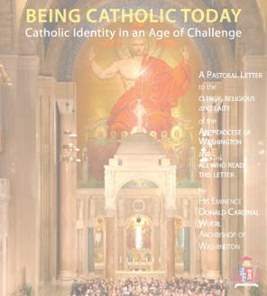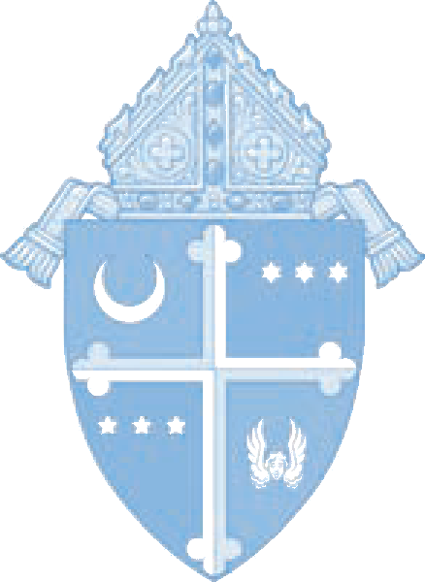

For Archdiocese of Washington Full-time and Part-time Employees

As the Church of Washington endeavors to live out Our Lord’s call to missionary discipleship (Matthew 28:16-20) and the invitation of Pope Francis to truly rejoice in the Joy of the Gospel, we recognize with gratitude the integral participation of all those with ministerial roles in the Church.

In support of the responsibilities entrusted to those who serve the Church, The Archdiocese has developed Catholic Ministry Formation opportunities for employees. The following outlines the required formation opportunities designed to help employees understand the commitment to serve in a ministerial role.

Annual Formation and Commissioning

Cardinal Wuerl’s pastoral letter, *Being Catholic Today: Catholic Identity in an Age of Challenge*, highlights the necessity of initial and continuing Catholic Ministry Formation. An initial formation is required of all employees to annually participate in a two-hour workshop focused on Catholic identity. This workshop is offered by each school’s pastor and/or principal as the spiritual leaders of the community.

Annually, employees both Catholic and Non-Catholic, will participate in reflection on Catholic Identity and new employees will be commissioned to serve and continue to grow as missionary disciples of the Lord. In this, the Church seeks to celebrate, highlight and publicly thank those who dedicate themselves to serving Christ in His mission. *Being Catholic Today*

resources can be found on the following webpage: adw.org/being-catholic-today/.

9

# Requirements for All Employees



## Living Catholic: Faith and Mission in Ministry

#### Current Employees Must Complete by June 30, 2018

New Employees Must Complete within two years from date of hire

This 7 hour workshop is built upon the Pillars of the *Catechism of the Catholic Church* and invites all employees to reflect, in a personal way, on the key teachings of the Catholic faith. This workshop includes opportunity for personal prayer and group sharing. The objective of the formation workshop is to present the truths of the faith and help prepare employees to share the faith with others.

**Pastors and principals should schedule Living Catholic training through the Office of Catechesis**

**<LivingCatholic@adw.org>.**

**Employees seeking to find an open Living Catholic session please visit www.adw.org/formation.**